Python Practice Tuple

248518 Gaurav B Raskar

Q.1. and Q.2.

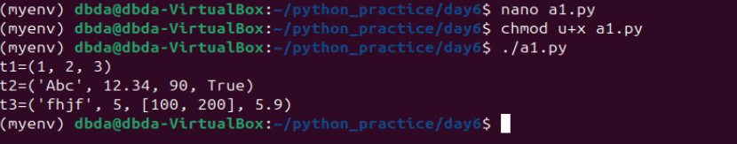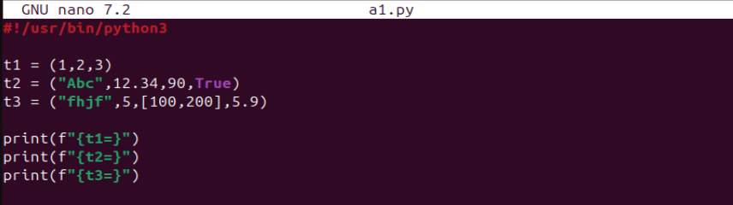

Q.3.

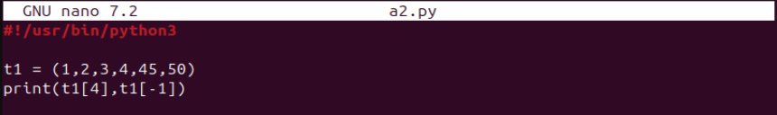

Q.4.

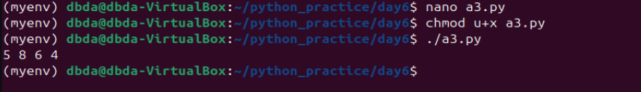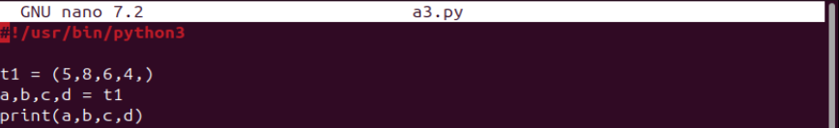

Q.5.

Cannot add element in tuple

Q.6.

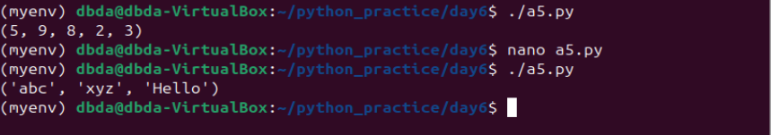

Q.7.

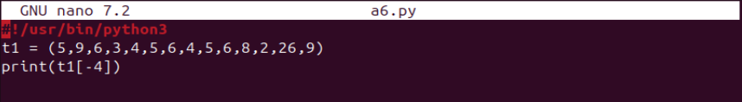

Q.8.

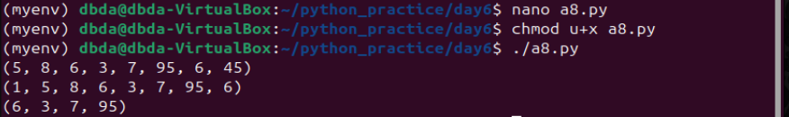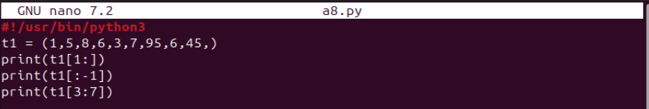

Q.9.

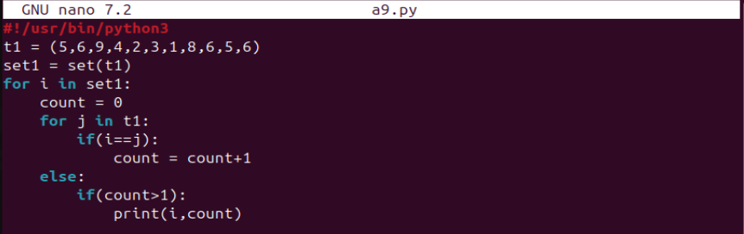

Q.10.

